Name-Ankan Pal

Note:

We need to make sureb that all packages need to be installed.

Before installing packages :

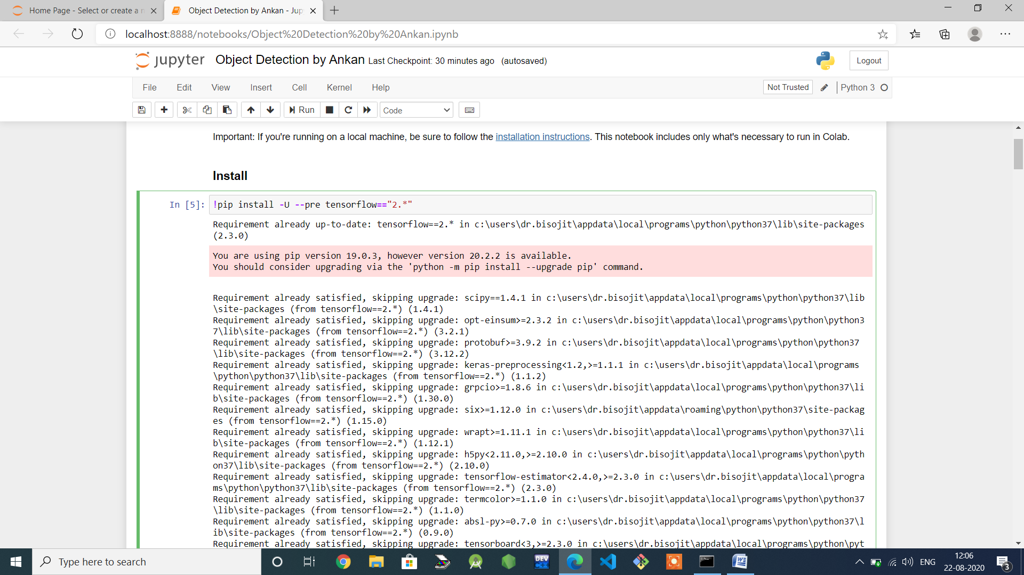

After installing packages :

